
MATHEMATICS APPLICATIONS
Test 2 2017-2018
Linear Functions
Resource Free
Marks: 47 Time Allowed: 50 minutes

TOTAL: 47 Name: _______________
ALL working must be shown for full marks.
For full marks you will need to show all your working out.

Question 1 [2,2,3,3,3,3 = 16 marks]
- Solve the following Linear functions

i) 4y - 6 = 30 ii) 4x + 12 = 3x + 6

iii) 3(x + 8) - 2 = 7 iv) 2x + 8 = -3(x + 2)

- Give the equation that represents the following situations and then solve to find the value of x.

- “Three times a number is divided by four and then two is added. The result is one less than the original number”

- “Twice a number divided by three subtracted from 10 results in four minus a number divided by 2”

Question 2 [3,3,1,2 : 9 marks]
For the tables and graphs given below
i) Decide if a linear relationship is shown.
ii) If table or graph is linear, give the linear equation.

x | -2 | -1 | 0 | 1 | 2
y | 5 | 8 | 11 | 14 | 17

a)

Linear: Yes / No

Rule:

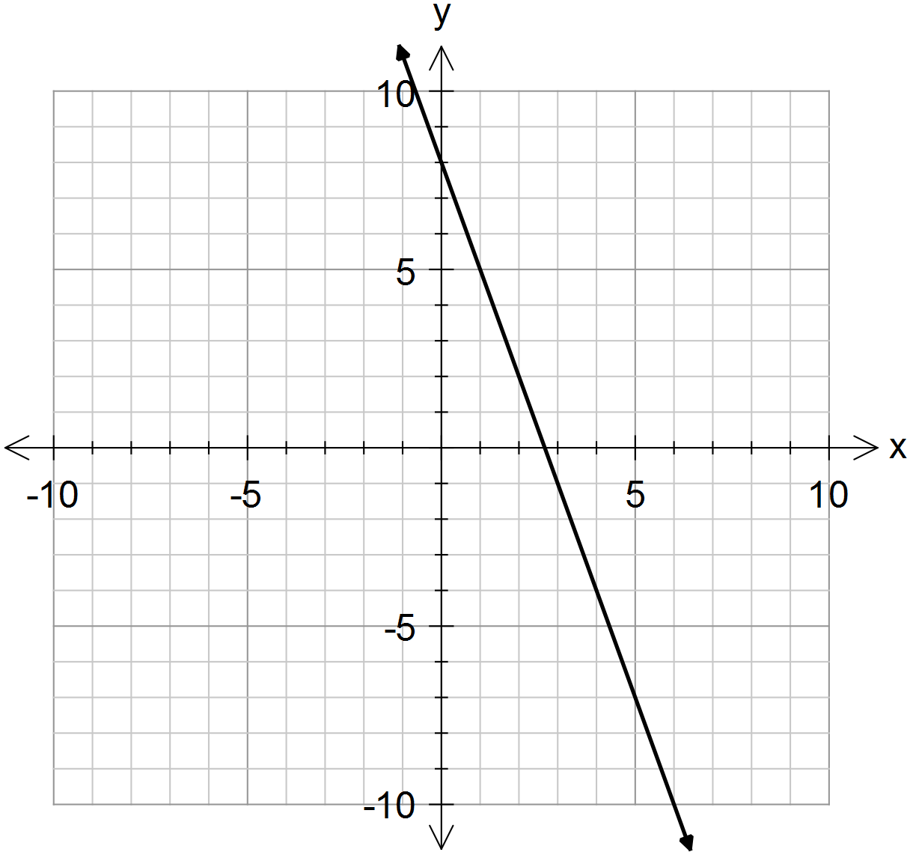b)

Linear: Yes / No
Rule:

x | 2 | -1 | 1 | 0 | -2
y | 10 | 12 | 14 | 16 | 18
c)

Linear: Yes / No
Rule:

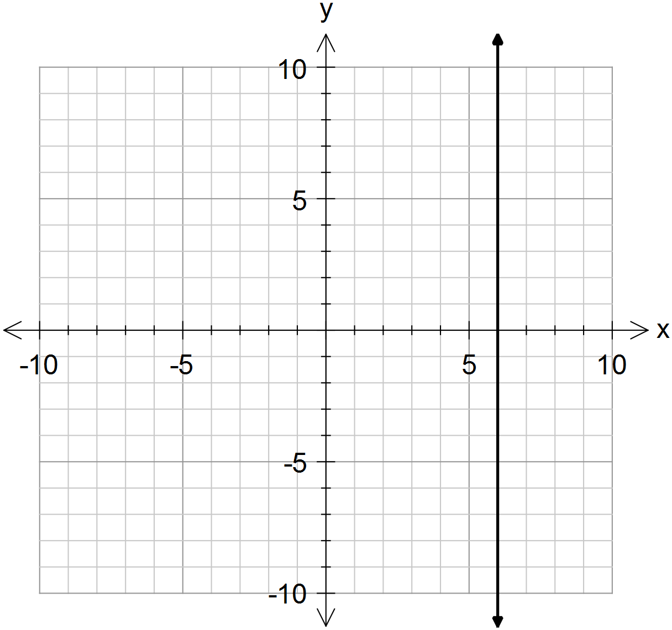
d)

Linear: Yes / No
Rule:

Question 3 [ 2, 2, 3 = 7 marks]

- For the function y = - 4x – 4, give the gradient and y intercept.

- For the function 3x - 2y = 30, give the x-intercept and y intercept.

- Sketch the functions above on the following axis. (must be ruled)

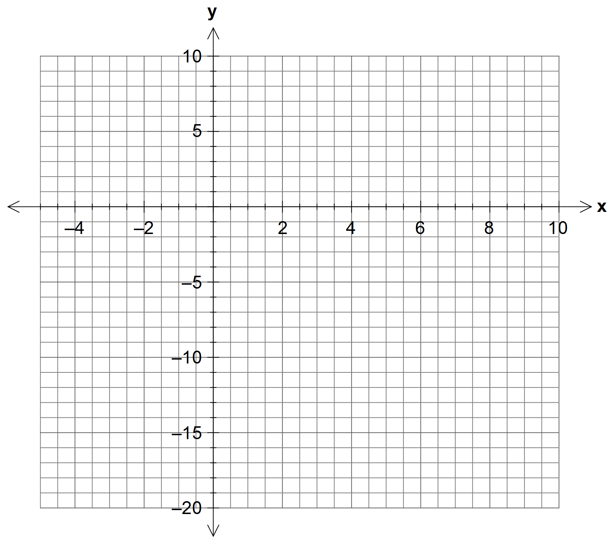

Question 4 [1,2,2,1,3,2,4 = 15 marks]
Amber is a plumber. She charges $60 for arriving at a job, and $75 per hour that she works.
- What is the independent variable in this relationship?

- Use the information above to complete this table
Time worked, t (hours) | 0 | 1 | 2 | 3 | 10
Cost,C($)

- Graph the data in the table on the axis below.

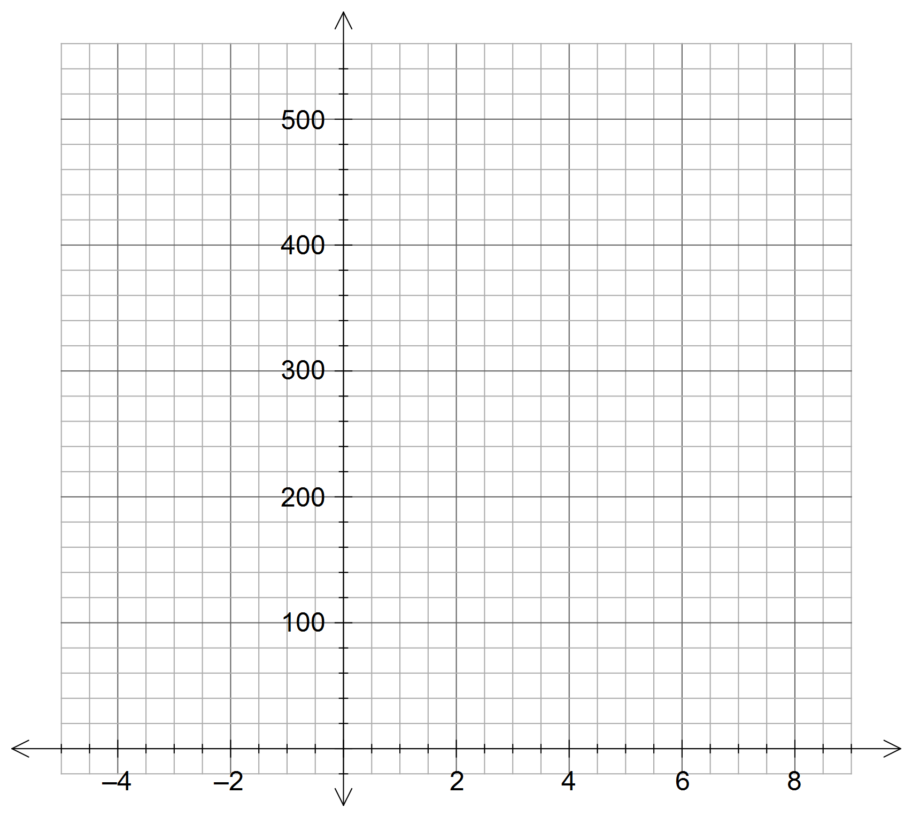

- What is the significance of the intercept on the y axis?

- Determine the equation of the line for the relationship between t and C.
(must be in terms of t and c)

- What is the significance of the Gradient?

- Use your graph to answer the following questions
i) How much would Amber charge for working 6 hours?

ii) How long has Amber worked if she charges $360?

